Name: __________________________ Date: __________________
Quotes About Goal Setting
Objective: Explore some perspectives on goal setting and determine whether they align with your own views.

Directions: Read and paraphrase the quotes below. Then, decide to what extent you agree with the quote.
Quote | Paraphrase the Quote | Do you agree with this quote? Why or why not?
“As soon as I accomplish one thing, I just set a higher goal. That’s how I’ve gotten to where I am.”
— Beyoncé, American singer, song-writer, and actress
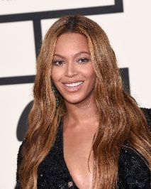
“Some of us have great runways already built for us. If you have one, take off! But if you don’t have one, realize it is your responsibility to grab a shovel and build one for yourself and for those who follow after you.”
— Amelia Earhart, American aviation pioneer and author
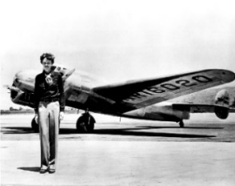

Quotes about Goal Setting (Continued)
Quote | Paraphrase the Quote | Do you agree with this quote? Why or why not?
“I’ve missed more than 9,000 shots in my career. I’ve lost almost 300 games. Twenty-six times I’ve been trusted to take the game winning shot and missed. I’ve failed over and over again in my life, and that is why I succeed.”
— Michael Jordan, American professional basketball player

“Effort makes you. You will regret someday if you don’t do your best now. Don’t think it’s too late to keep working on it. It may take time, but there’s nothing that gets worse due to practicing.”
— Jeon Jungkook, South Korean song writer and singer, member of the band BTS
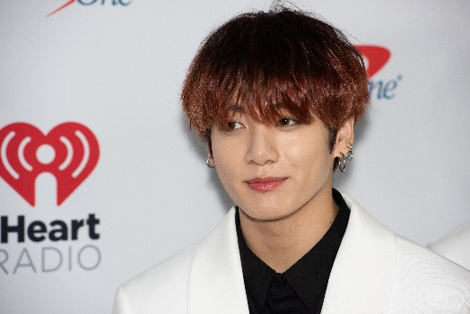

Quotes about Goal Setting (Continued)
Quote | Paraphrase the Quote | Do you agree with this quote? Why or why not?
“Set realistic goals, keep re-evaluating, and be consistent.”
— Venus Williams, American professional tennis player

“I know how it looks. But just start. Nothing is insurmountable.”
— Lin Manuel Miranda, American actor, songwriter, singer, playwright, and director; best known for creating and starring in the Broadway musicals Hamilton and In the Heights
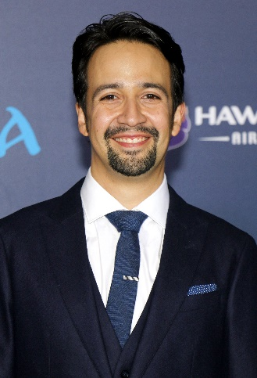

Stamp Your Learning for Quotes About Goal Setting
Directions: Answer the following questions in complete sentences.
- Which quote could be most impactful for you in your own life? How might you apply it, starting tomorrow?
__________________________________________________________________________________________________________________________________________________________________________________________________________________________________________________________________________________________________________________________________________________________________________________________________________________________________________________________________
- Select one of the individuals from the quotations list on pgs. 1 - 3. Craft a SMART goal they might create for themselves based on their profession.
__________________________________________________________________________________________________________________________________________________________________________________________________________________________________________________________________________________________________________________________________________________________________________________________________________________________________________________________________

