Name: __________________________ Date: __________________
Homeroom: _____________________
Quotes on Self-Reflection

Directions: Review the quotes below. Paraphrase what they mean (rewrite them in your own words) and then decide whether you agree with the quote. Explain why or why not.
Quote | Paraphrase the Quote | Do you agree with this quote? Why or why not?
“Knowledge of the self is the mother of all knowledge. So it is incumbent (necessary) on me to know myself, to know it completely.”

- Kahlil Gibran, Lebanese-American writer, poet and visual artist

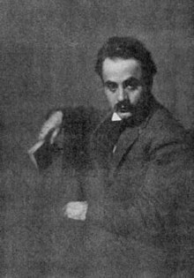
“Self-reflection is a humbling process. It’s essential to find out why you think, say, and do certain things – then better yourself.”

-Sonya Teclai, American singer and writer



Quotes on Self-Reflection (Continued)
Quote | Paraphrase the Quote | Do you agree with this quote? Why or why not?
“Before anything else, preparation is the key to success.”

-Alexander Graham Bell, credited with inventing and patenting the first practical telephone

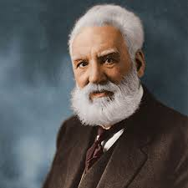
“Blessed are those who can laugh at themselves, for they shall never cease to be amused.”

- Anonymous

Quotes on Self-Reflection (Continued)
Quote | Paraphrase the Quote | Do you agree with this quote? Why or why not?
“Don't bother just to be better than your contemporaries (current peers) or predecessors (people who came before you). Try to be better than yourself.”

-William Faulkner, American writer and Nobel Prize laureate. Faulkner wrote novels, short stories, screenplays, poetry, essays, and a play

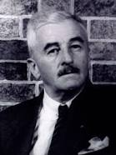
“The unexamined life is not worth living.”
- Socrates, a classical Greek philosopher credited as one of the founders of Western philosophy, and as being the first moral philosopher of the Western ethical tradition of thought.
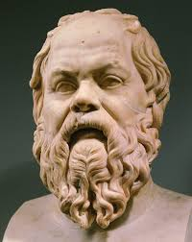

Stamp Your Learning for Quotes on Self-Reflection
Directions: Answer the following questions in complete sentences.

- Which quote is your favorite quote and why?

____________________________________________________________________________________________________________________________________________________________________________________________________________________________________________________________________________________________________________________________________________________________
_______________________________________________________________________________________

- Which of the quotes would you share with others? Why?

____________________________________________________________________________________________________________________________________________________________________________________________________________________________________________________________________________________________________________________________________________________________
_______________________________________________________________________________________

- Explain a recent time you used self-reflection and how it supported you. If you haven’t self-reflected recently, think of a time when self-reflection would have been helpful.

____________________________________________________________________________________________________________________________________________________________________________________________________________________________________________________________________________________________________________________________________________________________
_______________________________________________________________________________________

