Name: __________________________ Date: __________________
Quotes About Respect
Objective: Explore some perspectives on respect and determine whether they align with your own views.

Directions: Read and paraphrase the quotes below. Then, decide to what extent you agree with the quote.
Quote | Paraphrase the Quote | Do you agree with this quote? Why or why not?
“To be one —to be united — is a great thing, but to respect the right to be different is maybe even greater.”
— Bono,
Irish singer-songwriter, lead singer of band U2
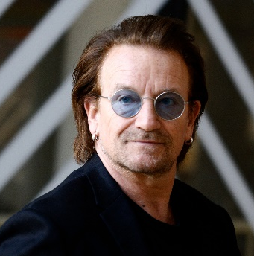
“I’m not concerned with your liking or disliking me…all I ask is that you respect me as a human being.”
— Jackie Robinson, American professional baseball player
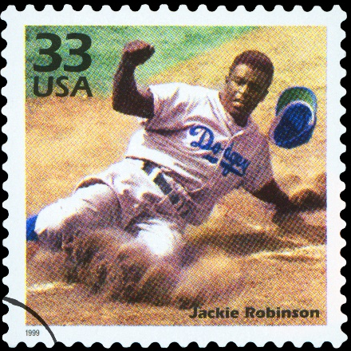

Quotes About Respect (Cont’d)
Quote | Paraphrase the Quote | Do you agree with this quote? Why or why not?
“Everyone should be respected as an individual, but no one idolized.”
— Albert Einstein, German-born physicist
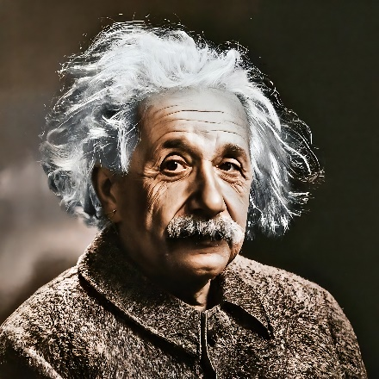

“Once you figure out what respect tastes like, it tastes better than attention.”
— Pink, American musician

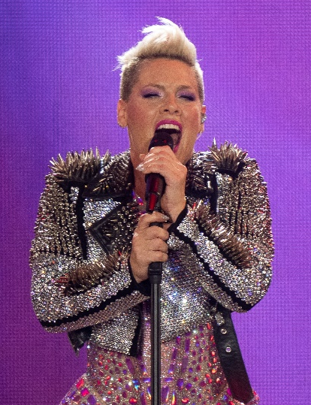

Stamp Your Learning for Quotes About Respect
In Lesson A, What is Respect?, we defined respect as demonstrating high regard for someone, or treating yourself and others in a way that shows concern and support.
- Taylor Swift has been quoted as saying, “No matter what happens in life, be good to people. Being good to people is a wonderful legacy to leave behind.” How does this quote relate to the definition of respect above?
__________________________________________________________________________________________________________________________________________________________________________________________________________________________________________________________________________________________________________________________________________________________________________________________________________________________________________________________________

- Which of the four quotes resonated most with you? Explain.
__________________________________________________________________________________________________________________________________________________________________________________________________________________________________________________________________________________________________________________________________________________________________________________________________________________________________________________________________

