Name: __________________________ Date: ________________________
Homeroom: _____________________ Class: _______________________

“There Will Come Soft Rains” (Day 1) “The morning house lay empty”
Lesson Objective: Analyze Bradbury’s depiction of relationships between technology and humanity.
Do Now
Directions: Read the article below and answer the questions that follow. You may wish to consult your Knowledge Organizer for additional information on the terms in bold.

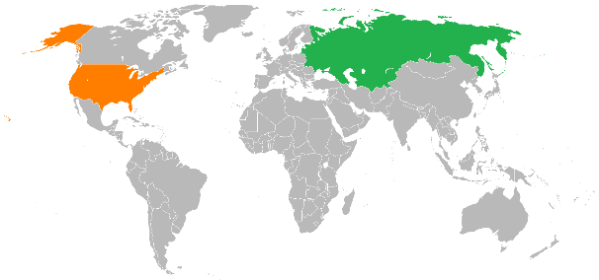
The Cold War and Nuclear Anxiety
In August of 1945, the United States dropped two atomic bombs on Japan, at Hiroshima and Nagasaki, ending World War II. An atomic bomb is a nuclear weapon which derives massive destructive force from nuclear reactions and is capable of devastating entire cities by blast, fire, and radiation. Scientists worked for decades to understand and harness nuclear technology, and the creation of the atomic bomb was at the cutting edge of scientific advancement of the time.
Map of the USSR and USA
Even though the United States and the Soviet Union had been allies during World War II, after the war ended, both nations maneuvered to increase their power and influence across the globe. By 1947, the conflict between the U.S. and USSR was known as the Cold War, so named because it never escalated into open war between the two powers. The term was first used by writer George Orwell in a 1945 article to refer to what he predicted would be a nuclear stalemate between “two or three monstrous super-states, each possessed of a weapon by which millions of people can be wiped out in a few seconds.”
The Soviet Union detonated its first nuclear weapon in 1949, ending the United States’ monopoly on nuclear power. Both governments spent massive amounts of money to increase the quantity and power of their nuclear arsenals. Some historians believe that some form of Cold War between the two nations would have arisen whether or not the United States had dropped atomic bombs on Japan, but many see the bombing of Hiroshima and Nagasaki as a turning point in the conflict between two superpowers.
- Why might the United States’ use of the atomic bomb have been a “turning point” in the conflict between the United States and the Soviet Union?
________________________________________________________________________________________________________________________________________________________________________________________________________________________________________________________________________________________________________________________________________________________________________________
- Consider the timeline of stories on your knowledge organizer. “Robbie” was first published in 1940. “There Will Come Soft Rains” (the story we will read today) was published in 1950. What significant events occurred in world history between these two dates, based on the article above? Add them to the timeline below.
“There Will Come Soft Rains” published
“Robbie” published

1950
1940

- Recall this quote from Isaac Asimov: Science fiction can be defined as that branch of literature which deals with the reaction of human beings to changes in science and technology.
What “changes in science and technology” occurred between the publication of “Robbie” and “There Will Come Soft Rains”? How might science fiction deal with these changes?
________________________________________________________________________________________________________________________________________________________________________________________________________________________________________________________________________________________________________________________________________________________________________________

Vocabulary: Manifest, Sublime

Word | Definition | Related  Parts of Speech | Situations | Image
manifest  verb | to show something plainly or to make it clear | manifest  adjective  manifestation  noun  manifestly  adverb | - Some diseases take a long time to manifest themselves; patients may have no symptoms for years.  - ____________________________________________  ____________________________________________  ____________________________________________ | 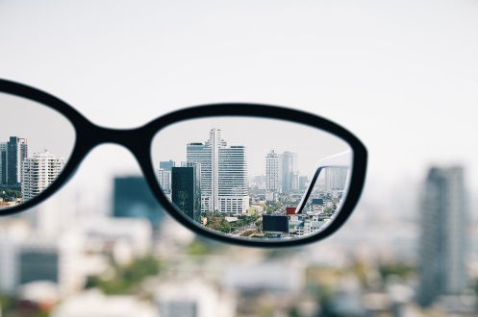
sublime  adjective | - expressing a deep truth  - to be of high or inspiring value | sublime  verb  sublime  noun  sublimely  adverb | - Judging by the satisfied look on both men's faces, the meal was sublime.  - ____________________________________________  ____________________________________________  ____________________________________________ | 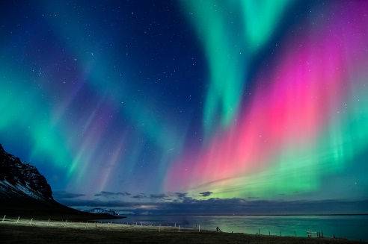

Vocabulary Active Practice

As we apply our new word knowledge, be sure to use the vocabulary word in your answer!

- Sublime comes from the Latin root sublimis meaning literally high or elevated. Why might someone describe a piece of art or music as sublime?

- How might a parent manifest their disapproval to a child who colored on the wall?

- In science, to sublime or sublimate means to go immediately from solid to gas, skipping the transition to a liquid. How might this verb be connected to the meaning of sublime as an adjective?

- If a friend was feeling disconsolate, how might those feelings be manifested?

- Imagine someone tells you they have proof that a ghost manifested in their kitchen. What do they mean? How would you react? Why?

- How might anxieties about nuclear war manifest in science fiction stories?
____________________________________________________________________________________________________________________________________________________________________________________________________________________________________________________________

Pages 96-97
Annotation Task: As you read annotate any descriptions of futuristic technology in the story as well as any hints of incongruity (anything unexpected or out of place).
Futuristic Technology | Incongruity
- Turn and Talk: Describe the characters and setting of this story. In what year is the story set? Does anything strike you as odd?

- Reread these lines from p. 97:
At eight-thirty the eggs were shriveled and the toast was like a stone. An aluminum wedge scraped them into the sink, where hot water whirled them down a metal throat which digested and flushed them away to the distant sea. The dirty dishes were dropped into a hot washer and emerged twinkling dry.
- Who prepared this breakfast? When? For whom? Why might the eggs be “shriveled” and the toast “like a stone”?
______________________________________________________________________________________________________________________________________________________________________________________________________________________________________________________________________________
- Consider this line from the excerpt:
An aluminum wedge scraped them into the sink, where hot water whirled them down a metal throat which digested and flushed them away to the distant sea.
What do you notice about the changes in bold? What might Bradbury be highlighting with the word choice of the original?
An aluminum wedge scraped them into the sink, where hot water whirled them down a metal drain which processed and flushed them away to the distant sea.
________________________________________________________________________________________________________________________________________________________________________________________________________________________________________________________________________________________________________________________________________________________________________
Pages 97-98
- Turn and Talk: What do you think happened to the city? What makes you think so? Consider the historical context in your Do Now.
Nuclear Shadows
On August 6, 1945, at the end of World War II, an American plane dropped an atomic bomb above Hiroshima, Japan, sending a mushroom cloud billowing into the sky. Nearly 80,000 people are believed to have been killed immediately, with possibly another 60,000 survivors dying of injuries and radiation exposure by 1950.
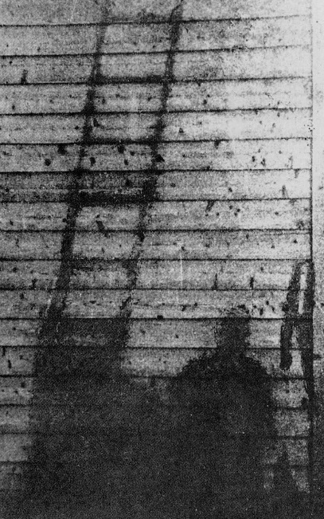
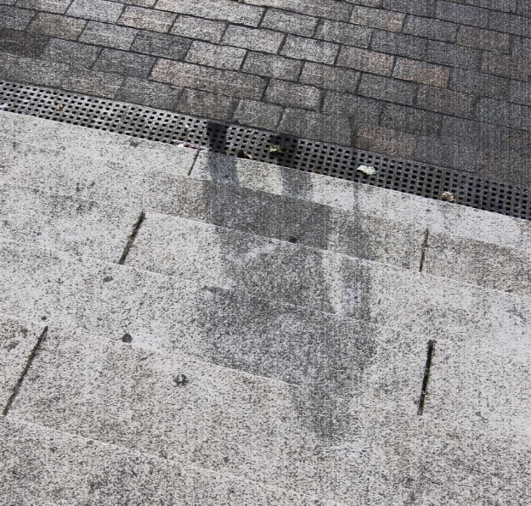
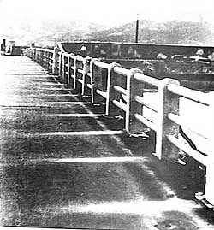
The intense heat of the atomic explosion caused what are called nuclear shadows. The blast of heat and radiation changed the colors of surfaces, but objects or bodies blocking the blast prevented this color change in some places and created haunting impressions on steps, pavements, and walls. Shockingly clear imprints or “shadows” of human figures remain throughout the city.
The silhouette of a ladder and a human figure imprinted by the heat of the nuclear explosion.
The unshielded surface of the bridge was scorched; the surface blocked by the handrail appears as a white shadow.
A human shadow marks the steps of a bank in Hiroshima, imprinted when the heat from the bomb burned the surrounding stone white.
- Consider the reading above and the article we read in the Do Now.
- Turn and Talk: What are the “five spots of paint” described on p. 97?
- How might the details of this scene manifest the fears of readers in the 1950s?
__________________________________________________________________________________________________________________________________________________________________________________________________________________________________________________________________________________________________________________________________________________________________________________________________________________________________________________________________
- Reread these lines from p. 97:
Nine-fifteen, sang the clock, time to clean.
Out of warrens in the wall, tiny robot mice darted. The rooms were acrawl with the small cleaning animals, all rubber and metal. They thudded against chairs, whirling their mustached runners, kneading the rug nap, gently sucking at hidden dirt. Then, like mysterious invaders, they popped into their burrows. Their pink electric eyes faded. The house was clean.
Ten o’clock. The sun came out from behind the rain. The house stood alone in a city of rubble and ashes. This was the one house left standing. At night the ruined city gave off a radioactive glow which could be seen for miles.
- Turn and Task: Annotate any evidence of technology described in this excerpt. How does Bradbury imagine technology will change in the future?

- What technology is not explicitly named but is still present in the story? Consider the final paragraph of the excerpt above. Challenge: Why might some technologies be described in detail and other only hinted at?
________________________________________________________________________________________________________________________________________________________________________________________________________________________________________________________________________________________________________________________________________________________________________
- Contrast these two uses of technology. How would you describe his view on these technological advancements? Explain your thinking.
__________________________________________________________________________________________________________________________________________________________________________________________________________________________________________________________________________________________________________________________________________________________________________________________________________________________________________________________________

Pages 98-100: On Your Own
Annotation Task: As you read, annotate any descriptions of nature or natural elements (animals, trees, etc.). Consider the relationship between nature and technology.
Notes

- Expand the kernel sentence below, using each of the following guidelines.
The dog returned.
- Begin with the word “When.”
____________________________________________________________________________________________________________________________________________________________________________________
- Add the word “but.”
____________________________________________________________________________________________________________________________________________________________________________________
- Begin with the word “After” and embed a quote from p. 98.
____________________________________________________________________________________________________________________________________________________________________________________
- Describe the actions of the house’s technology in this scene. How does it make you feel as a reader?
________________________________________________________________________________________________________________________________________________________________________________________________________________________________________________________________________________________________________________________________________________________________________

Pages 100-102
- Turn and Talk: Explain the irony of these lines:
But too late. Somewhere, sighing, a pump shrugged to a stop. The quenching rain ceased. The reserve water supply which had filled baths and washed dishes for many quiet days was gone.
- Recall Asimov’s description of robots as “[creatures] of metal, without soul or emotion.” Compare Bradbury’s depiction of the house. How are they similar? How are they different? Explain your thinking.
____________________________________________________________________________________________________________________________________________________________________________________________________________________________________________________________________________________________________________________________________________________________________________________________________________________________________________________________________________________________________________________________________________________________
Additional Insights
______________________________________________________________________________________________________________________________________________________________________________________________________________________________________________________________________________

Name: __________________________ Date: ______________________

Homeroom: _____________________ Class: _____________________
Exit Ticket
- In one artful sentence, describe the events of August 4, 2026.
________________________________________________________________________________________________________________________________________________________________________________________________________________________________________________________________________________________________________________________________________________________________________
- Read this quote from Isaac Asimov:
Over the past two centuries, we have watched our society grow more and more machine-made, so to speak; and I assume that in one of our possible futures, machines will continue to play more and more of a part in our society – in fact, to the point where machines may eventually "take over."
How might Bradbury respond to this quote? Why do you think so?
________________________________________________________________________________________________________________________________________________________________________________________________________________________________________________________________________________________________________________________________________________________________________
- Challenge: Who or what are the characters in this story? Explain your thinking.
________________________________________________________________________________________________________________________________________________________________________________________________________________________________________________________________________________________________________________________________________________________________________

Name: __________________________ Date: ________________________
Homeroom: _____________________ Class: ________________________
Homework
Directions: Read the essay below and answer the questions that follow.
Excerpt from “You and the Atomic Bomb”
By George Orwell (1945)
George Orwell was an English writer best known for the novels Animal Farm and 1984.
Considering how likely we all are to be blown to pieces by it within the next five years, the atomic bomb has not roused so much discussion as might have been expected. The newspapers have published numerous diagrams, not very helpful to the average man, of protons and neutrons doing their stuff, and there has been much reiteration of the useless statement that the bomb “ought to be put under international control.” But curiously little has been said, at any rate in print, about the question that is of most urgent interest to all of us, namely: “How difficult are these things to manufacture?”
Such information as we – that is, the big public – possess on this subject has come to us in a rather indirect way, apropos of President Truman’s decision not to hand over certain secrets to the USSR. Some months ago, when the bomb was still only a rumour, there was a widespread belief that splitting the atom was merely a problem for the physicists, and that when they had solved it a new and devastating weapon would be within reach of almost everybody. (At any moment, so the rumour went, some lonely lunatic in a laboratory might blow civilisation to smithereens, as easily as touching off a firework.)
Had that been true, the whole trend of history would have been abruptly altered. The distinction between great states and small states would have been wiped out, and the power of the State over the individual would have been greatly weakened. However, it appears from President Truman’s remarks, and various comments that have been made on them, that the bomb is fantastically expensive and that its manufacture demands an enormous industrial effort, such as only three or four countries in the world are capable of making. This point is of cardinal importance, because it may mean that the discovery of the atomic bomb, so far from reversing history, will simply intensify the trends which have been apparent for a dozen years past.
It is a commonplace that the history of civilisation is largely the history of weapons. […] And though I have no doubt exceptions can be brought forward, I think the following rule would be found generally true: that ages in which the dominant weapon is expensive or difficult to make will tend to be ages of despotism, whereas when the dominant weapon is cheap and simple, the common people have a chance. Thus, for example, tanks, battleships and bombing planes are inherently tyrannical weapons, while rifles, muskets, long-bows and hand-grenades are inherently democratic weapons. A complex weapon makes the strong stronger, while a simple weapon – so long as there is no answer to it – gives claws to the weak.
[…]
From various symptoms one can infer that the Russians do not yet possess the secret of making the atomic bomb; on the other hand, the consensus of opinion seems to be that they will possess it within a few years. So we have before us the prospect of two or three monstrous super-states, each possessed of a weapon by which millions of people can be wiped out in a few seconds, dividing the world between them. It has been rather hastily assumed that this means bigger and bloodier wars, and perhaps an actual end to the machine civilisation. But suppose – and really this the likeliest development – that the surviving great nations make a tacit agreement never to use the atomic bomb against one another? Suppose they only use it, or the threat of it, against people who are unable to retaliate? In that case we are back where we were before, the only difference being that power is concentrated in still fewer hands and that the outlook for subject peoples and oppressed classes is still more hopeless.
[…]
We were once told that the aeroplane had “abolished frontiers”; actually it is only since the aeroplane became a serious weapon that frontiers have become definitely impassable. The radio was once expected to promote international understanding and co-operation; it has turned out to be a means of insulating one nation from another. The atomic bomb may complete the process by robbing the exploited classes and peoples of all power to revolt, and at the same time putting the possessors of the bomb on a basis of military equality. Unable to conquer one another, they are likely to continue ruling the world between them, and it is difficult to see how the balance can be upset except by slow and unpredictable demographic changes.
For forty or fifty years past, Mr. H. G. Wells and others have been warning us that man is in danger of destroying himself with his own weapons, leaving the ants or some other gregarious species to take over. Anyone who has seen the ruined cities of Germany will find this notion at least thinkable. Nevertheless, looking at the world as a whole, the drift for many decades has been not towards anarchy but towards the reimposition of slavery. We may be heading not for general breakdown but for an epoch as horribly stable as the slave empires of antiquity. [Few] people have yet considered its ideological implications – that is, the kind of world-view, the kind of beliefs, and the social structure that would probably prevail in a state which was at once unconquerable and in a permanent state of “cold war” with its neighbours.
Had the atomic bomb turned out to be something as cheap and easily manufactured as a bicycle or an alarm clock, it might well have plunged us back into barbarism, but it might, on the other hand, have meant the end of national sovereignty and of the highly-centralised police State. If, as seems to be the case, it is a rare and costly object as difficult to produce as a battleship, it is likelier to put an end to large-scale wars at the cost of prolonging indefinitely a “peace that is no peace”.
- Why does Orwell believe the development of the atomic bomb will result in “power [being] concentrated in still fewer hands”?
________________________________________________________________________________________________________________________________________________________________________________________________________________________________________________________________________________________________________________________________________________________________________
- Why might Orwell mention “the aeroplane” and “the radio” in the essay’s sixth paragraph? What larger point is he making about the impact of technology?
______________________________________________________________________________________________________________________________________________________________________________________________________________________________________________________________________________

