At a Glance – “My Little Countess”
- Lesson Objective: Describe the story elements and identify moments of contrast in “The Stolen Party.”
- In the Story: A young girl, Rosaura, has been invited to a birthday party for the daughter of the family for whom her mother works as a housekeeper. While Rosaura looks forward to celebrating with her friend, her mother, Herminia, worries that Rosaura won’t be welcome among the rich guests. Rosaura has a lovely time at the party, even getting special attention from a magician and his monkey. However, an unexpected encounter with Senora Ines, the lady of the house, ends the story with shattered illusions.
- Key Questions: Questions 1, 3, 4, 8, and 9 are the most important questions of the day and should not be skipped.
- Words to Watch For:
  - pompously (p. 2): with a high opinion of one’s own importance
  - boisterous (p. 2): noisy, energetic, rowdy
  - amusing (p. 4): enjoyable
  - sissy (p. 4): an offensive term to call someone a coward
  - countess (p. 4): a girl or woman of high, noble status
- Homework Options:
  - Quotes about Liliana Heker’s writing (attached)
  - Knowledge Organizer review
  - Questions from the lesson that were skipped for time
Agenda:
- Do Now (10 minutes)
- Explicit Vocabulary and Active Practice (10 minutes)
- Introduce the Unit (1 minute)
- Cycle 1 – Read Aloud: Pages 1-2 (10-15 minutes)
- Cycle 2 – FASE Reading or Read Aloud: Pages 2-3 (10-15 minutes)
- Cycle 3 – FASE Reading or Read Aloud: Pages 3-4 (10 minutes)
- Cycle 4 – FASE Reading or Read Aloud: Pages 4-5 (15-20 minutes)
- Exit Ticket (10 minutes)

Lesson Plan

Do Now (10 minutes)
- Give students 5-6 minutes to examine the images and answer both questions, then review using Cold Call, share out, or a brief discussion.
- Q1: What joke does this cartoon seem to be making about short stories?
  - The cartoon seems to suggest that short stories are so short that they sometimes miss big pieces of narrative – this story isn’t really a story at all, it’s just familiar phrases (the beginning and end) from stories and fairy tales. The joke might also be that short stories get right to the point without any extra or wasted details.
- Q2: What might it mean that “more is suggested” in a short story than in a novel? What might that mean for us as readers of short stories?
  - This might mean that not everything in a short story is explained or resolved, and that we as readers have to do more work and read more attentively to interpret the meaning. We might also have to be comfortable with a lack of explanation or resolution.
Explicit Vocabulary Instruction (10 minutes) — Ashamed, Delicate
- Teach each word to students, one at a time.
- Read or ask a student to read the example sentence that includes the vocabulary word.
- Shift focus to how the picture demonstrates the word (while projecting the image).
- Lead Active Practice questions

Introduce the Novel (1 minute)
- Frame: Before beginning to read, give students a 1-2 sentence explanation of the new unit. You may choose to use or adapt the following language:
  - I’m excited to begin our new unit. Over the next few weeks, we’ll be reading six well-known, highly regarded short stories. While each of these stories is written about and during very different times and places, we’ll also notice some ideas and techniques that are common to them all. Our first story, written by Argentine author Liliana Heker, is called “The Stolen Party.” It tells the story of a young girl named Rosaura’s surprising day at a birthday party.

Cycle 1 (10-15 minutes) — Pages 1-2
- Read: Read Aloud the first few paragraphs, pausing after “How lovely you look today, Rosaura.”
- Write: Ask students to respond to Q1a-c. You might choose to remind students that they need not respond in complete sentences and can simply jot their initial thoughts.
- Discuss: Lead a brief discussion whole group to surface the key ideas. You might Cold Call strong responses to support pacing.
  - Key Ideas:
    - Q1a: Why does Rosaura’s mother seem skeptical of Rosaura attending the party?
      - Rosaura’s mother seems skeptical because she thinks it’s “a rich people’s party” and Rosaura, as the maid’s daughter, doesn’t belong there. She doesn’t think Luciana really sees her as a friend.
    - Q1b: Given Rosaura’s mother’s feelings, what might seem surprising about her starching Rosaura’s dress? What might this suggest about her?
      - Even though she doesn’t really approve of her going, Rosaura’s mother still makes sure that Rosaura looks her best. This might suggest that she cares about her daughter, and that she cares about what the people at the party will think of her.
    - Q1c: Where does Rosaura go first when she gets to the party, and why?
      - Rosaura goes right to the kitchen to see if there’s really a monkey at the party since her mother didn’t believe there would be. Rosaura might be thinking that if her mother was wrong about the monkey, she might be wrong about Luciana being her friend, too.
- Write: Ask students to respond to Q2.
- Discuss: Share out several strong responses. You might choose to use Show Call to highlight student work.
  - Key Ideas:
    - Q2: Possible Sentences:
      - Unlike Rosaura, Luciana is wealthy and lives in a big house.
      - In contrast with Rosaura, who thinks Luciana has invited her to her birthday party because they’re friends, her mother thinks that Luciana only sees Rosaura as the maid’s daughter.

Cycle 2 (10-15 minutes) – Pages 2-3
- Read: Read Aloud or use FASE Reading to read pp. 2-3, pausing after, “never been so happy in all her life.”
- Write: Ask students to skim the chapter to find evidence and respond to Q3, then answer Q4.
- Discuss: You might choose to Show Call strong annotations for Q3. Lead a brief discussion of Q3-Q4 to surface the key ideas.
  - Key Ideas:
    - Q3: Reread this section of text and underline moments of contrast between Rosaura and the other party guests. How do these contrasts seem to impact Rosaura? Why?
- Possible Annotations:
  - Rosaura was the only one allowed in the kitchen. Señora Ines had said: “You yes, but not the others, they’re much too boisterous, they might break something.”
  - She wasn’t a butterfingers, like the others.
  - Just then, Señora Ines arrived saying shh shh, and asked Rosaura if she wouldn’t mind helping serve out the hot dogs, as she knew the house so much better than the others.
- These contrasts seem to make Rosaura feel proud and special. Señora Ines seems to trust her more than the other guests, and Rosaura feels closer to Luciana because she gets special privileges and responsibilities that the others don’t. She feels different from, and even better than, the others.
- Note: Students might also notice the contrast in personality and/or relationship between Rosaura and the girl with the bow. While this is a valid contrast, the goal here is to push students to notice the more subtle contrast of Rosaura’s competence and familiarity with the house relative to the others’.
- Q4: What are your impressions of Señora Ines so far? How does she seem to feel about Rosaura?
  - Responses may vary but will likely be mostly positive; Senora Ines seems to be kind to and protective of Rosaura. She says Rosaura looks “lovely” when she arrives, and she comes to interrupt the unpleasant conversation that Rosaura is having with the girl in the bow.

Cycle 3 (10 minutes) – Pages 3-4
- Read: Read Aloud or use FASE Reading to read pp. 3-4, pausing after, “one could see that she was beaming.”
- Write: Ask students to Turn and Task to respond to Q5.
- Discuss: Lead a brief discussion by taking hands or using Cold Call to surface key ideas.
  - Key Ideas:
    - Q5: This section of our reading begins with the line, “But the best was still to come.” Which two moments of the party does Rosaura seem to consider to be “the best”? Why? What do these moments have in common?
      - Rosaura’s best moments are passing out the cake and being complimented by the magician. Both of these moments make her feel powerful and superior to the other party guests, and also make her feel like a part of a different social class than she really is; in each, she is compared to a royal or noble person.
        - Rosaura remembered a story in which there was a queen who had the power of life or death over her subjects. She had always loved that, having the power of life or death.
        - And before Rosaura returned to her seat, the magician said, “Thank you very much, my little countess.” She was so pleased with the compliment that a while later, when her mother came to fetch her, that was the first thing she told her.
Cycle 4 (15-20 minutes) – Pages 4-5
- Read: Read Aloud or use FASE Reading to read pp. 4-5 and finish the story.
- Write: Ask students to jot reflections in response to Q6, then Turn and Talk to share their reflections and respond to Q7.
- Discuss: Take hands or use Cold Call to share 1-3 reactions to the ending, then lead a brief discussion of Q7 to surface the key ideas.
  - Key Ideas:
    - Q6: How did the end of the story make you feel? Why?
      - Many possible responses (disappointed, surprised, upset, etc.); teachers should share out reactions and responses that demonstrate understanding of the twist ending.
    - Q7: Consider your initial impressions of Rosaura, Herminia, and Señora Ines. Has your opinion of any of these characters changed? How and why?
      - Many possible responses; opinions are most likely to have changed (for the negative) about Senora Ines, who embarrasses Rosaura and Herminia. Herminia might seem more sympathetic now, and Rosaura might seem more naïve or foolish.
- Write: Ask students to respond to Q8.
- Discuss: Use Show Call to share a few strong student responses.
  - Possible Sentence:
    - Q8: In one carefully written sentence, describe the contrast between Rosaura’s perspective and Señora Ines’s perspective. Begin your sentence with the word, “While.”
      - While Rosaura thought she had been invited to the party as a guest and friend, Señora Ines thought Rosaura was there as an employee.
- Write: Ask students to complete the chart in Q9a and respond to Q9b. You might choose to have students complete this with a partner or in small groups.
- Discuss: Use Show Call to highlight strong responses and surface key ideas.
  - Key Ideas:
    - Q9a: Using your Knowledge Organizer to help you, fill out the chart below with the story elements of “The Stolen Party.” Describe the setting, rising action, climax, and falling action/resolution of the story.
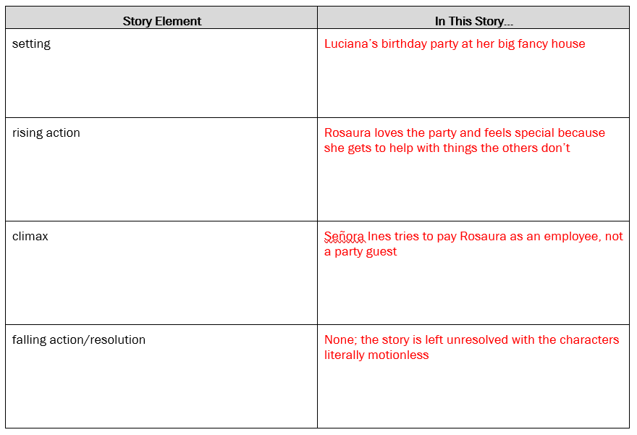
- Q9b: What do you notice about the elements of this story that seem to be typical of a short story?
  - Many possible responses; teachers should especially highlight the twist ending and the lack of any clear resolution.
- Write: Ask students to respond to Q10.
- Discuss: Lead a brief discussion to surface a variety of responses.
  - Key Ideas:
    - Q10: Why do you think this story is called “The Stolen Party”?
      - Students will answer this question again in subsequent lessons as they deepen their understanding of the story; on Day 1, student responses will likely be a bit more surface-level and plot-driven. Students might say that Señora Ines “stole” the party from Rosaura by treating her like an employee.

Exit Ticket (10 minutes)
- Q1. In one clear sentence, describe a contrast between Rosaura and another character.
  - Many possible responses; students should draw on a contrast that was discussed during the lesson.
- Q2. Explain one way in which the story elements of “The Stolen Party” are typical of a short story.
  - Many possible responses; students should draw on an idea that was discussed during the lesson.
Homework Answers
- Choose one of the quotes above and circle it, then paraphrase it on the lines below.
- Cortazar: Liliana Heker does amazing things with her writing. She takes simple, everyday events and gives them importance and value. She is intelligent and intimidating. Everyone should read her.
- Yale: Heker’s stories show that even small actions or events can be hugely important. In lovely, brief stories closely focused on human relationships, Heker gives us a quick and meaningful peek into the worlds of her stories.
- Trytten: Heker focuses on small moments when something hidden is finally shown, and this has huge impact that cannot be undone. A person’s life includes many events that don’t matter much and a few events that they will remember forever.
- How might the quote you chose apply to “The Stolen Party”?
- Many possible responses; regardless of the quote, students should mention the way in which a small, seemingly unimportant moment (like Senora Ines reaching out with money) actually has huge consequences for the feelings of Rosaura and her mother.

